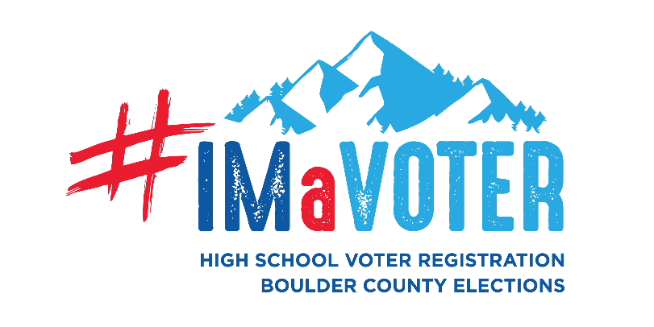
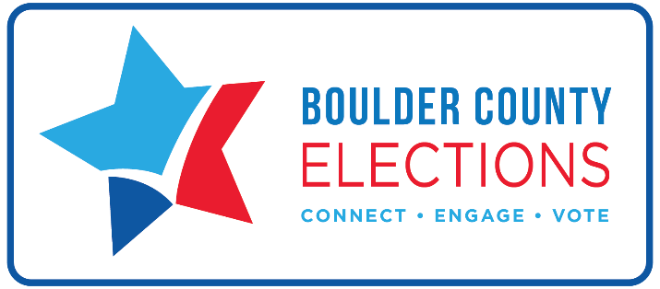

Below are sample PA loud system / video announcement scripts for your students to used during the week celebration for Student Voter Registration Awareness week. Feel free to edit or add to this content. This is just meant as a guide!

MONDAY: This week is Student Voter Registration Awareness Week! Get registered today by going to www.GoVoteColorado.gov or find [add High School Liaison name], our school’s voter registration liaison, to get a paper registration form.
TUESDAY: Student Voter Registration week continues! Be on the lookout for opportunities to register to vote at school (add details), as well as other voting information in your classes, on the Boulder County Elections page on Instagram, and on BoCo Clerk on Twitter. If you’ve got an opinion on our country’s future, register to vote at www.GoVoteColorado.gov to make sure your voice is heard!
WEDNESDAY: We are halfway through Student Voter Registration Awareness Week! Any student that is 16-years-old can pre-register to vote. If you’ve got a license, permit, or state ID, hop online to register at www.GoVoteColorado.gov or find [add High School Liaison name], our school’s voter registration liaison, to get a paper registration form.
THURSDAY: Make sure you’re ready to have your voice heard – register to vote TODAY as part of Student Voter Registration Week! Anyone ages 16 and older can register / pre-register. Find [HS Liaison Name] and ask how!
FRIDAY: Today is the last day of High School Voter Registration Awareness Week! There is no deadline to register to vote, but why wait? See [Liaison’s name] – our school’s voter registration liaison – today or visit www.GoVoteColorado.gov. Don’t forget: Voting is your Super Power.

